*Heap Data Structure*

A heap is a special tree-based data structure in which the tree is a ***complete binary tree*** (all levels are completely filled except possibly the last level and the last level has all keys as left as possible). Because it is a complete tree, a heap is also *balanced* so it has a height of *log(n).* Generally, heaps can be of two types:

1. **Max-Heap**: In a Max-Heap the key present at the root node must be greatest among the keys present at all of its children. The same property must be recursively true for all sub-trees in that Binary Tree.
2. **Min-Heap**: In a Min-Heap the key present at the root node must be minimum among the keys present at all of its children. The same property must be recursively true for all sub-trees in that Binary Tree.

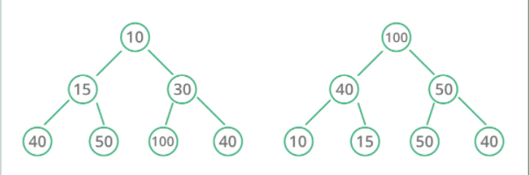

*Heapsort*

*Time complexity: O(n logn)*

